Exercise:
Riemannian geometry
Albert Einstein developed the special theory of relativity in order to describe the physical world that we live in using a different perspective than that of Isaac Newton. As he developed this theory, Einstein did not incorporate gravitation.
Now, if we go back to the dot product in Rn we just studied during this week and use the information we gathered, we can develop another dot product that is used in R4 when R4 represents space-time.
Consider a pair of twins named Michael and Leila on planet Earth who are separated immediately after birth. Leila remains on earth and Michael is put on a space ship to a distant star called, Faiza, x light-years away at some relativistic speed. As soon as Michael arrives at Faiza, he immediately returns to Earth with the same speed. On reaching Earth, the mathematical theory of special relativity predicts that he will find that his twin sister Leila who remained on earth is few years older than he is. Unbelievable, right? Well let see how this phenomenon can be explained by Einstein's model.
This model as mentioned above is a space-time that involves four coordinates in R4 with three space coordinates, x1, x2, x3, and a time coordinate x4. For two arbitrary vectors
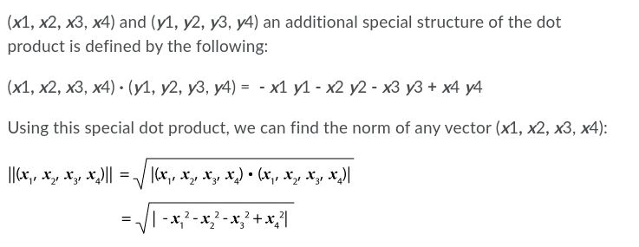

Questions:
- Describe briefly, in your own words, the space-time diagram where Leila advances in time, x4, while Michael in the spaceship advances in time and also moves in the direction of x1 between planet Earth and the star, Faiza.
Hint: remember the isosceles triangle and there is no motion in x2 or x3 coordinates. Start at (0, 0, 0, 0) for one corner of your isosceles triangle.
From the formula we can see we are using a dot product.
(x1,x2,x3,x4)(y1,y2,y3,y4) = -x1y1 -x2y2 -x3y3+x4y4
In the movement of the twins x1,x2,x3 are consonants, x4 is related to their reference. We perceive time as absolute as well as space but this is not the case as we get closer to the speed of light. As a person travels at the speed of light their perception of an object which is moving at the speed of light will be different than ours. Imagine a ball being thrown forward in a car moving the speed of light, its velocity would be speed of light + velocity of ball. In the reference a person in the car they see the ball at a normal throwing velocity but to others not moving at the speed of light the view of the ball being thrown will happen at a different time. In the case of the twins this is what is happening, because of the motion one twin x4 is changed while the other twin lacks the same motion so his/her x4 is different.
- If Faiza is located six light-years away from Earth, find the age of Michael upon reaching Earth when Leila is
  - 10 years old (students with last names from A to H).
Michael Velocity = 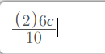
We can calculate perception of time for 10 year would be:
= 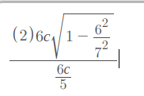
= 5.15078 years

Describe your vectors and how you reached your conclusion.

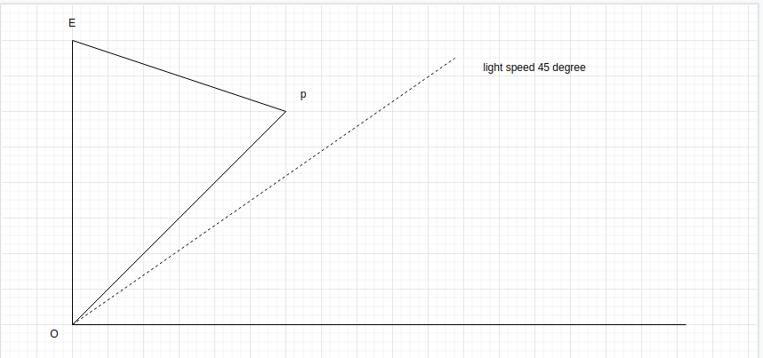
Michael movement is PE
Leila movement is OE
Michael length move will be from the following formula
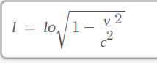
If we take into consideration the formula 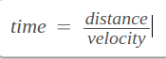
From the question we know lo = 6 light years.
Which we can derive Michaels time as the following:
= 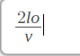
=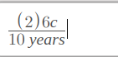
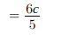
So ..
=
= 5.15078 years

